 | EUROPEAN COMMISSION  DIRECTORATE-GENERAL  INFORMATICS  Information Systems Directorate

European Commission
CIPADMIN Use Case Specification: UC0030 - e-TrustEx Admin Console - Manage Rentention Policy

Date: | 18/01/20173/05/2016
Version: | 21.000001
Authors: | Yves ADAM, Anamaria BATRINU
Revised by: | Cristian CHIRIAC, Anamaria BATRINU
Approved by:
Public:
Reference Number:
TABLE OF CONTENTS
Contents
Use-Case Description 6
1.1. Primary Actor 6
1.2. Definitions, Acronyms and Abbreviations 7
1.3. Functional features list 7
1.4. References 7
1.5. Context Diagram 8
1.5.1. CIPA Administration Console 8
1.5.2. Manage Retention Policy module 9
2. Flow of events 10
2.1. Basic single creation flow 10
2.1.1. User selects the Create Retention Policy menu action 10
2.1.2. System displays the "Create Retention Policy" page 10
2.1.3. User enters information 10
2.1.4. System creates the Retention Policy 10
2.1.5. System logs the creation 11
2.1.6. System notifies user of creation success 11
2.1.7. User acknowledges the creation 11
2.1.8. The System displays the Retention Policy in view mode 11
2.1.9. The basic single creation flow ends. 11
2.2. Basic search flow 11
2.2.1. User selects the Search Retention Policy menu action 11
2.2.2. System displays the "Search Retention Policy" page 11
2.2.3. User enters the search criteria 11
2.2.4. System searches the retention policies matching the entered criteria 11
2.2.5. The System displays the retention policies found 12
2.2.6. User views the result list 12
2.2.7. The basic search flow ends. 12
2.3. Basic Visualisation Flow 12
2.3.1. At 2.2.6, User selects a Retention Policy in the list 12
2.3.2. System opens the "Retention Policy Visualization" page 12
2.3.3. User visualises the details of the retention policy: 13
2.3.4. Visualization flow ends. 13
2.4. Basic Modification Flow 13
2.4.1. At2.3.3, User chooses to edit a retention policy 13
2.4.2. System opens the Retention Policy edit page: 13
2.4.3. User makes the changes 13
2.4.4. System saves the modified Retention Policy 13
2.4.5. System logs the modification 14
2.4.6. System notifies user of modification success 14
2.4.7. User acknowledges the modification 14
2.4.8. System redisplays the retention policy in view mode 14
2.4.9. The Modification flow ends. 14
2.5. Basic Deletion Flow 14
2.5.1. At 2.3.3, User chooses to delete the retention policy 14
2.5.2. System ask for deletion confirmation 14
2.5.3. User confirms the deletion 14
2.5.4. System deletes the retention policy 14
2.5.5. System logs the deletion 14
2.5.6. System notifies user of deletion success 14
2.5.7. The Deletion Flow ends. 14
2.6. Subflows 14
2.6.1. S1: User searches and selects a transaction 14
2.7. Alternative Flows 15
2.7.1. AC1: at step 2.1.4., Business Rules are not verified 15
2.7.2. AC2: at step 2.1.3, User chooses Cancel option 15
2.7.3. AC3: at step 2.1.3, User chooses Clear option 15
2.7.4. AM1: at step 2.4.4, Business Rules are not verified 15
2.7.5. AM2: at step 2.4.3, User chooses Cancel option 15
2.7.6. AM3: at step 2.4.3, User chooses Reset option 15
2.7.7. AS1: at step 2.2.4, the system does not find any retention policy for the given criteria 15
2.7.8. AD1: at step 2.5.1, Business Rules are not verified 15
2.7.9. A1: Quitting: At any step user, decides to quit the application 15
2.8. Exceptional Flows 16
2.8.1. E1: at steps 2.1.1, 2.2.1, 2.3.1, 2.4.1 and 2.5.1 user is not authorized for the operation 16
2.8.2. E2: at any step, a technical error occurs 16
3. Special Requirements 17
3.1. Interface(s) with other Systems 17
3.2. Security Requirements 17
3.3. Other Special Requirement 17
4. Preconditions 17
5. Post conditions 17
6. Additional Information 17
6.1. Business Rules 17
6.2. Includes 17
6.3. Extends 17
7. Mock-up screens 18
7.1. "Create Retention Policy" page 18
7.2. "Search Retention Policy" page 18
7.3. "View Retention Policy” page 19
7.4. “Modify Retention Policy" page 19
7.5. "Delete Retention Policy" page 19

Document History

Version | Date | Comment | Modified Pages
0.001 | 29/04/2016 | First draft | All
0.002 | 10/05/2016 | Correction after discussion with O. Derveau
1.000 | 26/05/2016 | CIPADMIN-493: Corrections generated by reviewing the use case. Proposals from ETRUSTEX-1388 taken into account. | All sections
1.001 | 08/06/2016 | Following Pablo's remark: Added "transaction mandatory" as BR, and specified the retention type RETENTION when creating. | Creation and Modification sections
1.002 | 26/10/2016 | ETRUSTEX-1392
2.000 | 18/01/2017 | ETRUSTEX-1937: Reorganizing CIPAdmin user roles

Use-Case Description
This use case depicts the sequence of actions that a user needs in order to create a Retention Policy. The document also describes the management actions that correspond to a Retention Policy, such as Update, Delete, View and Search.
The "Retention Policy" service is exposed on the CIPAdmin module of e-Trustex platform.
In the remainder of the document the CIPADMIN application will be referred to as the System.

Primary Actor
A human user can access the Manage Retension Policy feature via CIPAdmin interface. For detailed user access rights on each feature option, please see UC 0100 - eTrustEx Admin Console - Authenticate and Authorise User, section 6.3 User Access Rights.
In the remainder of the document, the user will be referred to as User or by his/her role, in those cases where role specific rules apply.

Definitions, Acronyms and Abbreviations
Acronym, Abbreviation or Definition | Explanation
CIPA | Common Infrastructure for Public Administrations
CIPADMIN | CIPA AdminConsole
Party | Usually an organisation using the platform to exchange business documents.
ADM | A user having General Administrator role. The General Administrator is the Administrator of the CIPAdmin application. ADM can do everything a Central or Local Business Owner can do, plus complete user configuration, profile, document, role, transaction and domain management.
CBO | A user having Central Business Owner role. The Central Business Owner is responsible for the organization and operation of a business domain and uses CIPA in his business context.
UC(s) | Use Case(s)

Functional features list
Please refer to the CIPADMIN Vision document [R1]
Release | Feature number | Feature description

References
Ref. | Reference | Title / description | Version | Date
[R1] | CIPADMIN-VISION | CIPADMIN Vision document | V.61-EN | 3/05/20163
[R2] | Retension Policy verify and apply UC | https://webgate.ec.europa.eu/CITnet/svn/ETRUSTEX/trunk/001 e-TrustEx/002 Requirements/Use Case Model/UC - Verify and Apply Retention Policy.doc

Context Diagram

CIPA Administration Console
The diagram below depicts all the Services available on the CIPA Administration Console for e-TrustEx platform. Depending on the user role, only a subset of those services is exposed on the e-TrustEx Administration Console home page.
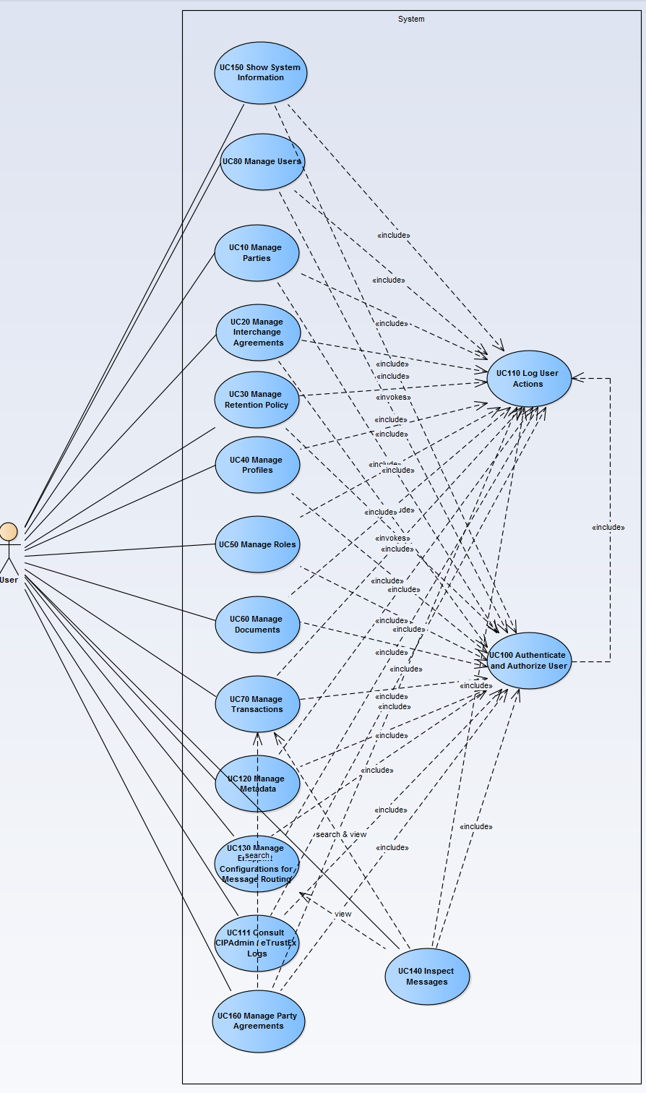

Manage Retention Policy module
The diagram below depicts how this use case interacts with other use cases implemented in the Administration Console.
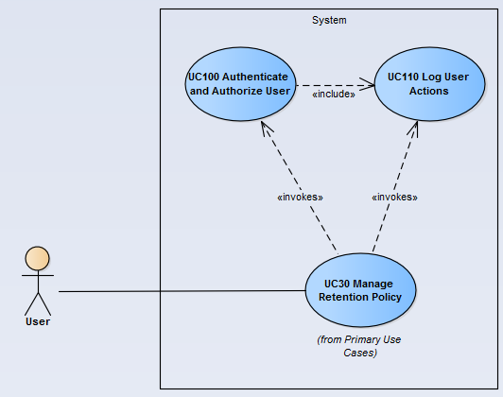

Flow of events
The conventions described in User Interface Generic Conventions document must be applied.

Basic single creation flow
ID | Description
UC0030_BR01 | User needs to have the correct access rights in order to access this feature. Please see UC 0100 - eTrustEx Admin Console - Authenticate and Authorise User, section 6.3 User Access Rights for more information.

User selects the Create Retention Policy menu action
The User chooses to create a new Retention Policy from the Retention Policy menu of the e-TrustEx Administration Console home page (Business Configuration > Retention policy > Create).

System displays the "Create Retention Policy" page
The System displays the 'Create Retention Policy' page as described in section "Create Retention Policy" page.

User enters information
- User populates all fields in the creation screen. For filling in a transaction, see subflow
- User chooses the Save option.

System creates the Retention Policy
ID | Description
UC0030_BR02 | The selected business domain must be one for which the User has access rights.
UC0030_BR03 | No other retention policy shall already exist for the specified transaction (identified by transaction name and version) in the context of the selected business domain.  However, the existence of a retention policy for a transaction having the same name but different version shall not obstruct the creation of the new retention policy in the same business domain.
UC0030_BR04 | "Duration" is mandatory.
UC0030_BR05 | "Duration" must be greater or equal to 1 day.
UC0030_BR06 | "Active" flag is mandatory (true or false).
UC0030_BR15 | Transaction is mandatory.
UC0030_BR16 | The retention type is automatically set to RETENTION by the System.

- The System validates the page according to the business rules.
- If any business rule is not verified, the system goes to alternate flow AC1.
- The system saves the Retention Policy and creates/makes the corresponding associations

System logs the creation
- System logs the successful creation of the Retention Policy: include use case Log CIPAdmin User Actions

System notifies user of creation success

User acknowledges the creation

The System displays the Retention Policy in view mode
- The System starts the basic visualisation flow from step 2.3.2.

The basic single creation flow ends.

Basic search flow
ID | Description
UC0030_BR01 | User needs to have the correct access rights in order to access this feature. Please see UC 0100 - eTrustEx Admin Console - Authenticate and Authorise User, section 6.3 User Access Rights for more information.

User selects the Search Retention Policy menu action
The User selects the Search option of the Retention Policy menu of the e-TrustEx Administration Console home page (Business Configuration > Retention policy > Search).

System displays the "Search Retention Policy" page
The System displays the search page as described in paragraph 7.2. "Search Retention Policies" page. The lists present in the search criteria shall be ascendant in alphabetical order ignoring case.

User enters the search criteria
- The User enters one or more search criteria. A search criterion left empty means the concerned field will not be taken into account. The user can search by:
  - Business domain
    - No selection = system will search for retention policies pertaining to any of the business domains the user is configured with
  - Transaction name
  - Active flag
    - No selection = both active and inactive retention policies are searched for
    - Yes = only active retention policies are searched for
    - No = only inactive retention policies are searched for
- The User chooses the search option.

System searches the retention policies matching the entered criteria
ID | Description
UC0030_BR07 | A field left empty or containing only spaces is not taken into account when searching.
UC0030_BR08 | Character case is ignored.
UC0030_BR09 | Trailing and leading spaces are ignored
UC0030_BR10 | Field value can contain a partial match.
UC0030_BR11 | At least one search field should be filled in.
UC0030_BR12 | If a single search field is filled in, it needs to contain at least 2 characters.  Concerned fields: free input text fields
The system searches the retention policies that satisfy all the entered criteria.

The System displays the retention policies found
The system displays the list of retention policies corresponding to the search criteria, showing the following information:
  - The business domain of the retention policy
  - The transaction name of the transaction to which the policy applies
  - The transaction version of the transaction to which the policy applies
  - The retention policy duration
  - The Active status
The result list is ordered alphabetically in ascending order on transaction name, ignoring case.

User views the result list
  - The User can view the details of a Retention Policy by clicking on the corresponding row (see Basic Visualisation Flow)
  - The User can launch a new search

The basic search flow ends.

Basic Visualisation Flow
ID | Description
UC0030_BR01 | User needs to have the correct access rights in order to access this feature. Please see UC 0100 - eTrustEx Admin Console - Authenticate and Authorise User, section 6.3 User Access Rights for more information.

At 2.2.6, User selects a Retention Policy in the list
(Alternative: in case the retention policy id is known, the user can directly enter the link in the web browser following the pattern http://hostname:port/etrustex-admin-web/retentionPolicy/<retentionPolicyId>/view.do, where retentionPolicyId is the id of the retention policy to visualize)

System opens the "Retention Policy Visualization" page
The System shows the Retention Policy visualization page as described in section "View Retention Policy” page:
- System reads the data
- System loads data on screen
- All fields are protected
- "Cancel", "Edit" and "Delete" buttons are made available

User visualises the details of the retention policy:
- User can return to the result list by choosing "Cancel", the view flow ends and basic search flow restarts at 2.2.5
- User can choose to edit or to delete a retention policy (see Basic Modification Flow and Basic Deletion Flow)

Visualization flow ends.

Basic Modification Flow
ID | Description
UC0030_BR01 | User needs to have the correct access rights in order to access this feature. Please see UC 0100 - eTrustEx Admin Console - Authenticate and Authorise User, section 6.3 User Access Rights for more information.

At 2.3.3, User chooses to edit a retention policy

System opens the Retention Policy edit page:
ID | Description
UC0030_BR13 | All fields can be modified.

User makes the changes
- User makes the desired changes
- User chooses the save option

System saves the modified Retention Policy
ID | Description
UC0030_BR13 | All fields can be modified.
UC0030_BR02 | The selected business domain must be one for which the User has access rights.
UC0030_BR03 | No other retention policy shall already exist for the specified transaction (identified by transaction name and version) in the context of the selected business domain.  However, the existence of a retention policy for a transaction having the same name but different version shall not obstruct the creation of the new retention policy in the same business domain.
UC0030_BR04 | "Duration" is mandatory.
UC0030_BR05 | "Duration" must be greater or equal to 1 day.
UC0030_BR06 | "Active" flag is mandatory (true or false).
UC0030_BR15 | Transaction is mandatory.
- The system validates the page according to the business rules.
- If any business rule is not verified, the system goes to alternate flow AM2.
- The system saves the Retention Policy.

System logs the modification
System logs the successful modification: include use case Log CIPAdmin User Actions

System notifies user of modification success

User acknowledges the modification

System redisplays the retention policy in view mode
See section "View Retention Policy” page.

The Modification flow ends.

Basic Deletion Flow
ID | Description
UC0030_BR01 | User needs to have the correct access rights in order to access this feature. Please see UC 0100 - eTrustEx Admin Console - Authenticate and Authorise User, section 6.3 User Access Rights for more information.
UC0030_BR14 | Only retention policies configured for one of the user's business domain can be deleted.

At 2.3.3, User chooses to delete the retention policy

System ask for deletion confirmation

User confirms the deletion
If user chooses to cancel the deletion, he is returned to the visualization page (2.3.3).

System deletes the retention policy
- System verifies the business rules
- System deletes the retention policy

System logs the deletion
System logs the successful deletion of the retention policy: Include use case Log CIPAdmin User Actions.

System notifies user of deletion success

The Deletion Flow ends.

Subflows

S1: User searches and selects a transaction
- System opens a Transaction Search Popup: include section 2.3. Basic Search Flow (from step 2.2.2. System displays the Search Transaction page) of Manage Transaction Use Case.
- System fills in the read-only input text field with the name and version of the transaction returned at previous step

Alternative Flows

AC1: at step 2.1.4., Business Rules are not verified
- System logs the error: include use case Log CIPAdmin User Actions
- The system notifies the user with the corresponding message.
- Alternate flow ends and basic creation flow restarts at 2.1.3.

AC2: at step 2.1.3, User chooses Cancel option
- System disregards all information provided by User
- System closes the page
- System redirects the user to CIPAdmin home page
- Use Case ends

AC3: at step 2.1.3, User chooses Clear option
- Systems disregards all information provided by the user
- Alternate flow ends and basic creation flow restarts at 2.1.2.

AM1: at step 2.4.4, Business Rules are not verified
- System logs the error: include use case Log CIPAdmin User Actions
- The system notifies the user with the corresponding message.
- Alternate flow ends and basic modification flow restarts at 2.4.3.

AM2: at step 2.4.3, User chooses Cancel option
- System disregards all information provided by User
- System closes the page
- Alternate flow ends and basic flow continues from step 2.3.3.

AM3: at step 2.4.3, User chooses Reset option
- Systems disregards all information provided by the user
- Alternate flow ends and basic modification flow restarts at 2.4.3.

AS1: at step 2.2.4, the system does not find any retention policy for the given criteria
- The system notifies the user that no retention policies have been found
- Alternate flow ends and basic search flow restarts at 2.2.3

AD1: at step 2.5.1, Business Rules are not verified
- System logs the error: include use case Log CIPAdmin User Actions
- The system notifies the user with the corresponding message
- Alternate flow ends and basic flow restarts at 2.3.3

A1: Quitting: At any step user, decides to quit the application
Use case ends.

Exceptional Flows

E1: at steps 2.1.1, 2.2.1, 2.3.1, 2.4.1 and 2.5.1 user is not authorized for the operation
Include the steps in section 2.4.1 of Authenticate and Authorise User Use Case.

E2: at any step, a technical error occurs
- System logs the error: include use case Log CIPAdmin User Actions
- The system informs the user about the error.
- Use case ends

Special Requirements

Interface(s) with other Systems

Security Requirements

Other Special Requirement

Preconditions
- User must be registered user of CIPAdmin tool
- User must be logged in & successfully authenticated on the e-TrustEx Admin Console (see UC 0100 - eTrustEx Admin Console - Authenticate and Authorise User)

Post conditions
- [Success] The Retention Policy has been successfully created, modified or deleted.
- [Failure] The System logs the failure reason and the context, the use case is aborted and the primary actor has been notified of the reasons.

Additional Information

Business Rules

Includes
- For operation authorization: UC 0100 - eTrustEx Admin Console - Authenticate and Authorise User
- For logging: UC 0110 - eTrustEx Admin Console - Log CIPAdmin User Actions

Extends
n/a

Mock-up screens

"Create Retention Policy" page
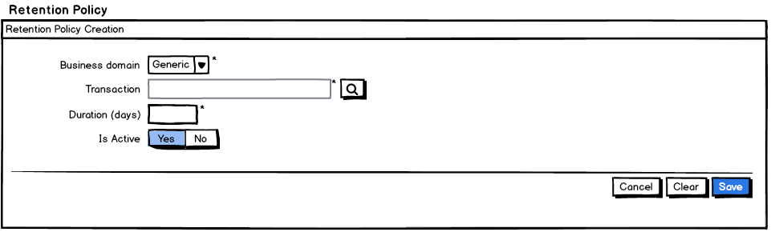
- Business domain list is populated with the user business domains and defaulted to the user business domain selected in the application header;
- Transaction field (contains the transaction name and transaction version) is read-only and automatically filled in by the system once the user selects a transaction in the transaction search screen accessed via the Search button near the transaction fields;
- All lists shall be alphabetically ordered in ascendant order and ignoring case;
- Starred fields are mandatory;
- Cancel, Clear and Save buttons are present.

"Search Retention Policy" page
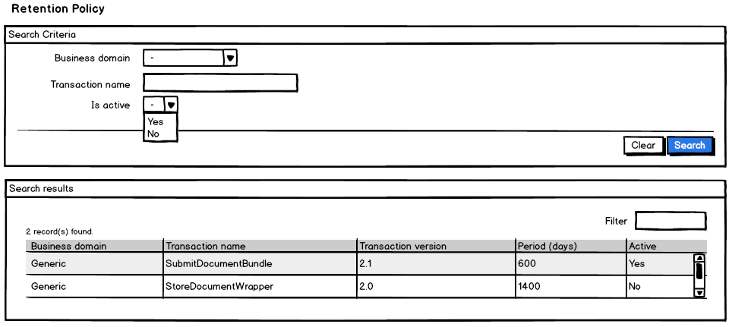
- Business domain list is populated with the user business domains;
- Any lists shall be alphabetically ordered in ascendant order and ignoring case; The results list shall be ordered by transaction name;
- Clear and Search buttons are present.

"View Retention Policy” page
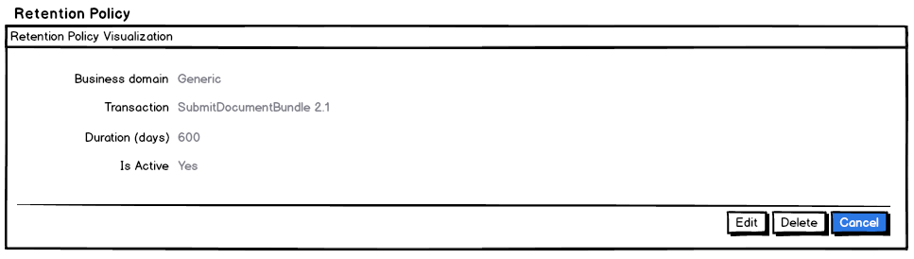

“Modify Retention Policy" page
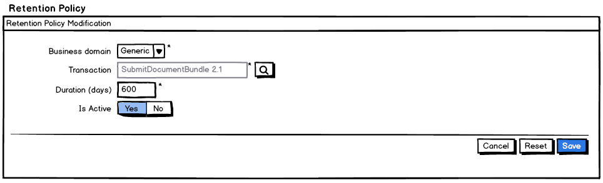

"Delete Retention Policy" page
